Employee Self-Service (ESS) Time Entry
Eligible employees are required to utilize the Employee Self-Service interface in myOleMiss to submit their attendances and absences for payroll. In general, permanent employees who do not record their time against Facilities Management or Telecommunications work orders are required to log into the myOleMiss portal to record their time. Employees who currently use approved time clock systems, student employees, and Rebel Reserve employees may not use the online timesheet and should continue to utilize Form UM4/HR12).
The ESS Timesheet and Time Approval applications use the reporting/routing relationship that is set up for annual performance appraisals. When an employee enters and submits their time using ESS, an email is sent to their supervisor notifying them that they have time to be approved. If a change is needed in the reporting relationship, please email Camie Rushing in the Department of Human Resources and include the name and employee number of employee(s) requiring changes. Alternatively, you may provide an updated organization chart.

Navigate to myOleMiss and log in using your WebID and password.
Click the Employee tab. Then, click the box to maximize the Apps selection box under “My HR Tools.”
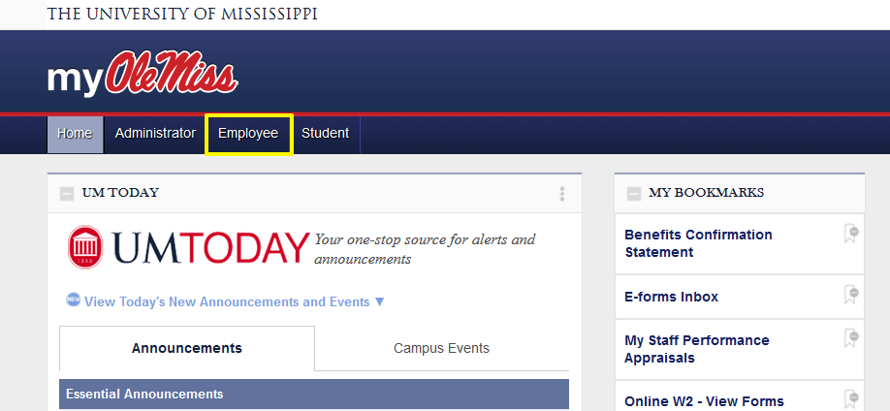

Click “Timesheet.”
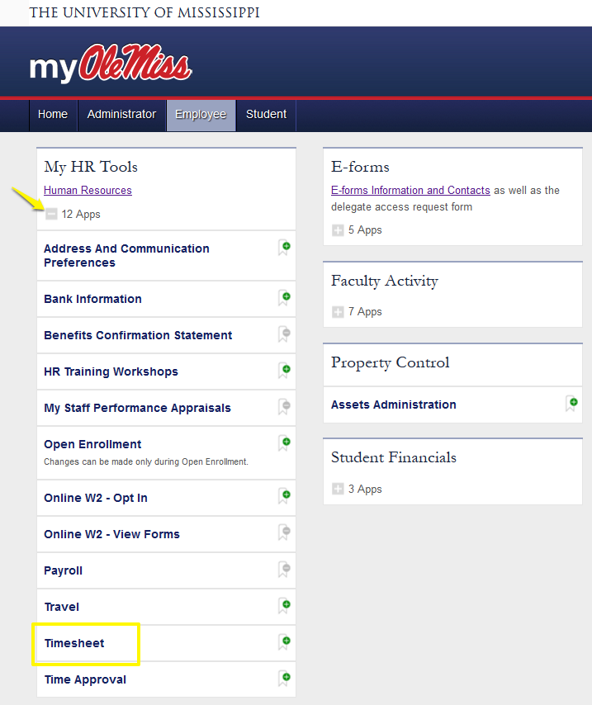

Once the timesheet is displayed, click the pay period in which the hours were worked or leave was taken. Enter the number of hours in the appropriate cell. Press Enter/Return on your keyboard to populate the daily and weekly totals. If you are satisfied with your entries, click “Submit for Approval.” You will then be prompted to certify that your entries are correct.
*Benefit-eligible faculty and salaried employees will only submit time when leave is taken (i.e. Vacation/Personal, Major Medical, etc.). See the example below.
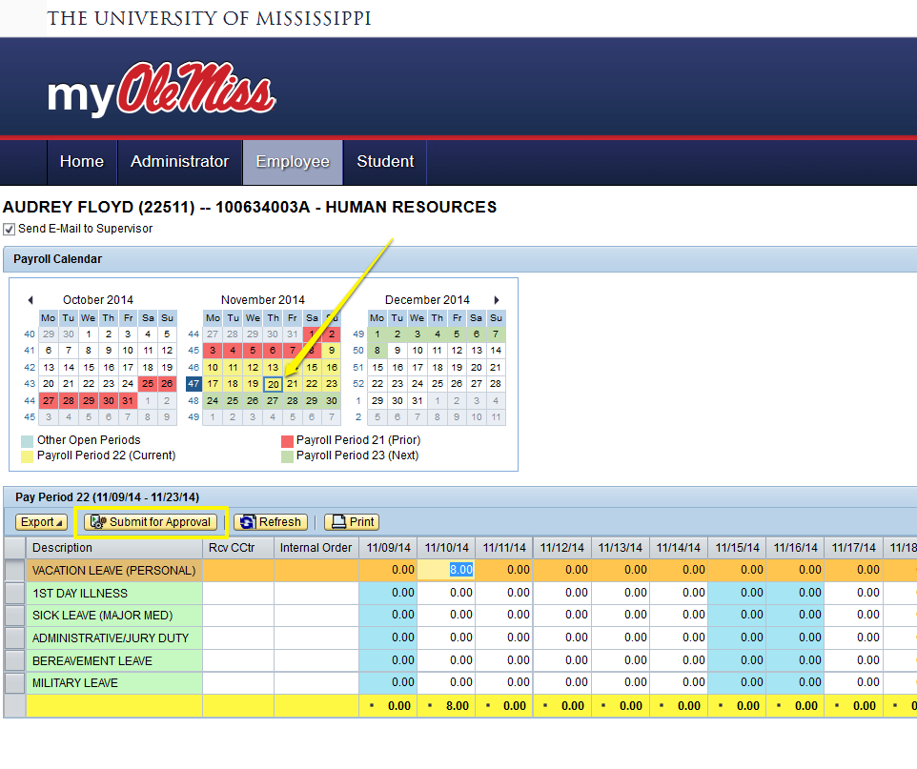

The box next to “Send Email to Supervisor” is checked by default. By clicking “Yes,” an email will be automatically generated to your department chair/supervisor notifying them that time has been submitted for their approval.
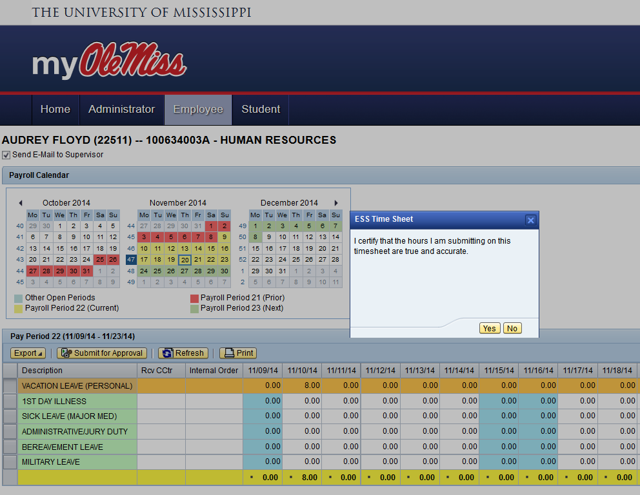
If you need assistance with ESS Time Entry, please contact the Payroll Office in Human Resources at (662) 915-7431 or payroll@olemiss.edu.

