Employee Self-Service (ESS) Time Approval
Supervisors are required to utilize the Employee Self-Service interface in myOleMiss to approve eligible employees’ attendances and absences for payroll. In general, permanent employees who do not record their time against Facilities Management or Telecommunications work orders are required to log into the myOleMiss portal to record their time. Employees who currently use approved time clock systems, student employees, and Rebel Reserve employees may not use the online timesheet and should continue to utilize Form UM4/HR12).
The ESS Timesheet and Time Approval applications use the reporting/routing relationship that is set up for annual performance appraisals. When an employee enters and submits their time using ESS, an email is sent to their supervisor notifying them that they have time to be approved. If a change is needed in the reporting relationship, please email Camie Rushing in the Department of Human Resources and include the name and employee number of employee(s) requiring changes. Alternatively, you may provide an updated organization chart.

Navigate to myOleMiss and log in using your WebID and password.
Click the Employee tab. Then, click the box to maximize the Apps selection box under “My HR Tools.”
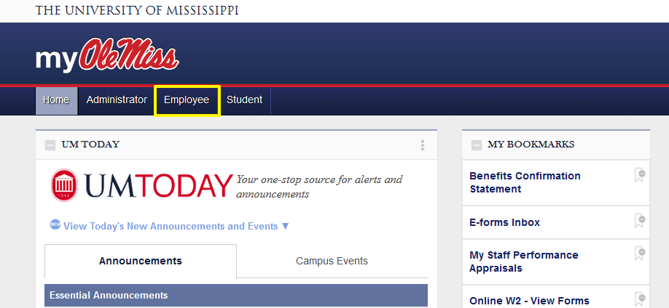

Click “Time Approval.”
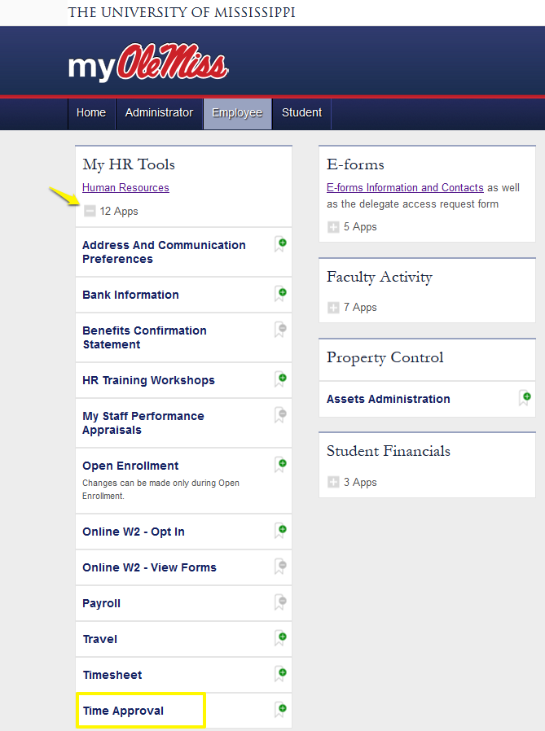

The displayed screen will show the Payroll Calendar above a listing of your direct reports.
NOTE: If you do not see any employee names, ensure your cursor is located in the pay period for which time has been submitted for approval.
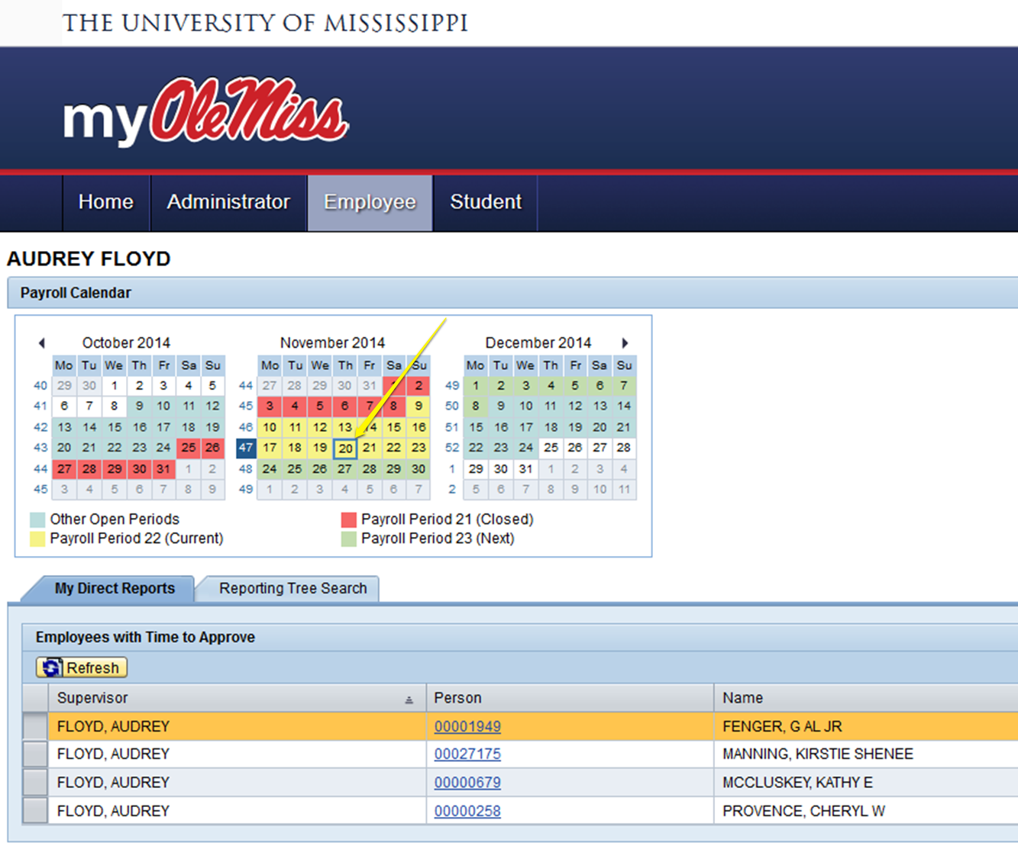

Click the personnel number for the employee whose time you wish to review and approve. Each day defaults to status “Approved.” If incorrect entries exist, contact the employee prior to submission.
You may click “View Emp. Timesheet” to display the timesheet in columnar format similar to below.
NOTE: your pop-up blocker must be disabled in order to view the timesheet.
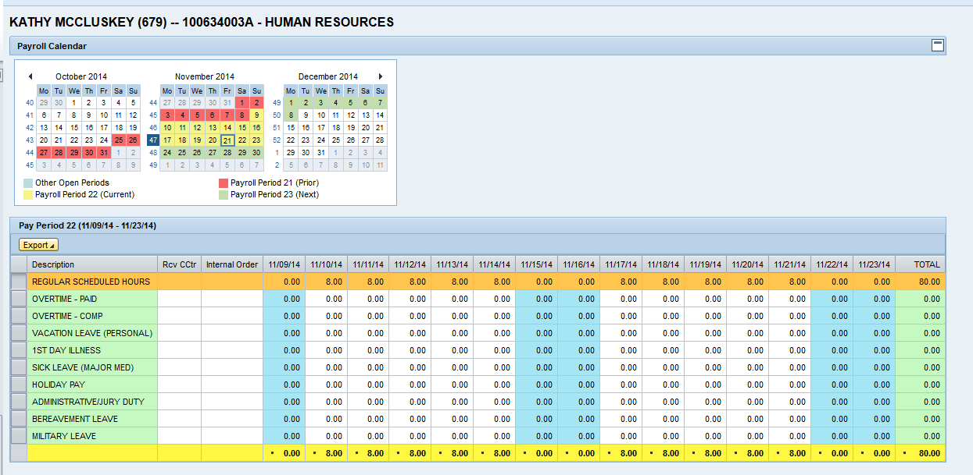

Once you have reviewed and verified the entries, click “Approve/Reject.” Entries with the status “Approved” are complete and require no further action.
NOTE: if an entry is incorrect, the employee may log in and make modifications prior to supervisor’s approval.
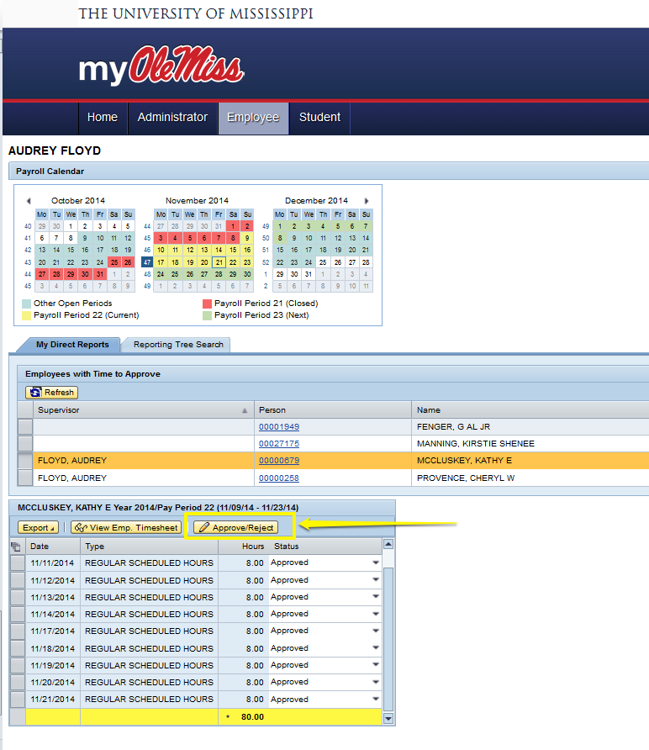
If you need assistance with ESS Time Approval, please contact the Payroll Office in Human Resources at (662) 915-7431 or payroll@olemiss.edu.

